**Code**

**UserInterface.java**

package com.bankAccount;

import java.io.DataInputStream;

import java.io.IOException;

//Parent class Account

class Account{

//Variables for user details

private String accountNumber;

private String customerName;

private double balance;

public Account(String accountNumbe,String customerName,double balance){

this.accountNumber=accountNumbe;

this.customerName=customerName;

this.balance=balance;

}

//Getter and setter method

public String getAccountNumber() {

return accountNumber;

}

public void setAccountNumber(String accountNumber) {

this.accountNumber = accountNumber;

}

public String getCustomerName() {

return customerName;

}

public void setCustomerName(String customerName) {

this.customerName = customerName;

}

public double getBalance() {

return balance;

}

public void setBalance(double balance) {

this.balance = balance;

}

//Display information

public void displayInformation() {

System.out.println("Customer Name "+getCustomerName());

System.out.println("Account Number "+getAccountNumber());

System.out.println("Account Balance "+getBalance());

}

}

//MaintenanceCharges interface

interface MaintenanceCharge{

public float calculateMaintenanceCharge(float noOfYear);

}

//Child class of Account class is CurrentAccount class

class CurrentAccount extends Account implements MaintenanceCharge{

float m=100;

public CurrentAccount(String accountNumbe,String customerName,double balance){

super(accountNumbe,customerName,balance);

}

public float calculateMaintenanceCharge(float noOfYear) {

float n=noOfYear;

return ((m*n)+(float)200);

}

}

//Child class of Account class is SavingAccount class

class SavingAccount extends Account implements MaintenanceCharge{

//base charges

float m=50;

float maintenanceCharge;

public SavingAccount(String accountNumbe,String customerName,double balance) {

super(accountNumbe,customerName,balance);

}

public float calculateMaintenanceCharge(float noOfYear) {

float n=noOfYear;

return ((m*n)+(float)50);

}

}

//Userinterface class for user information

public class UserInterface {

public static void main(String args[])throws IOException {

int choice;

float noOfYear;

String accountNum;

String customerName;

double balance;

float maintenanceCharge;

//creating object for taking user input

DataInputStream userInput=new DataInputStream(System.in);

System.out.println("1. Saving Account \n2. Current Account");

//For asking the user choice

System.out.println("Enter your choice: ");

choice=Integer.parseInt(userInput.readLine());

//If choice is 1 then it will calculate maintenance charges for savingAccount

//If choice is 2 then it will calculate maintenance charges for curreAccount

switch(choice){

case 1:

//Taking user input

System.out.println("Enter the Account number");

accountNum=userInput.readLine();

System.out.println("Enter the Customer Name");

customerName=userInput.readLine();

System.out.println("Enter the Balance amount");

balance=Double.parseDouble(userInput.readLine());

System.out.println("Enter the number of years");

noOfYear=Float.parseFloat(userInput.readLine());

//Creating object of SavingAccount class

SavingAccount savingAccount=new SavingAccount(accountNum, customerName, balance);

maintenanceCharge=savingAccount.calculateMaintenanceCharge(noOfYear);

savingAccount.displayInformation();

System.out.println("Maintenance Charge for Saving Account is Rs "+maintenanceCharge);

break;

case 2:

//Taking user input

System.out.println("Enter the Account number");

accountNum=userInput.readLine();

System.out.println("Enter the Customer Name");

customerName=userInput.readLine();

System.out.println("Enter the Balance amount");

balance=Double.parseDouble(userInput.readLine());

System.out.println("Enter the number of years");

noOfYear=Float.parseFloat(userInput.readLine());

//Creating object of currentAccount class

CurrentAccount currentAccount=new CurrentAccount(accountNum, customerName, balance);

maintenanceCharge=currentAccount.calculateMaintenanceCharge(noOfYear);

currentAccount.displayInformation();

System.out.println("Maintenance Charge for Current Account is Rs "+maintenanceCharge);

break;

default:

System.out.println("You have entered wrong choice..please try again");

break;

}

}

}

**Output for saving account:**

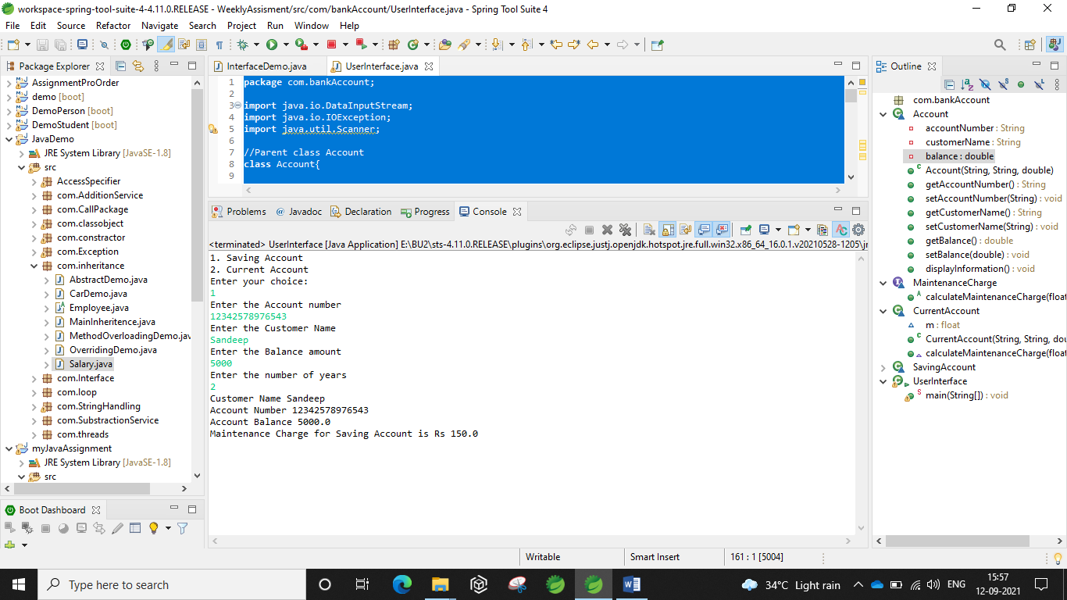

**Output for current account:**

